Overview:
The PortTesterAPI provides a way for game teams to detect firewalls by sending packets out to a server and having them come back on an previously-unused and unopened port. A UDP packet containing instructions on which incoming port to test is sent to a server. The server will then send back a specified number of UDP packets on a different port. By monitoring the number of packets received, it is possible to determine if a firewall between the client and the server might inhibit connections, including peer-to-peer communications between game consoles behind one or more firewalls.

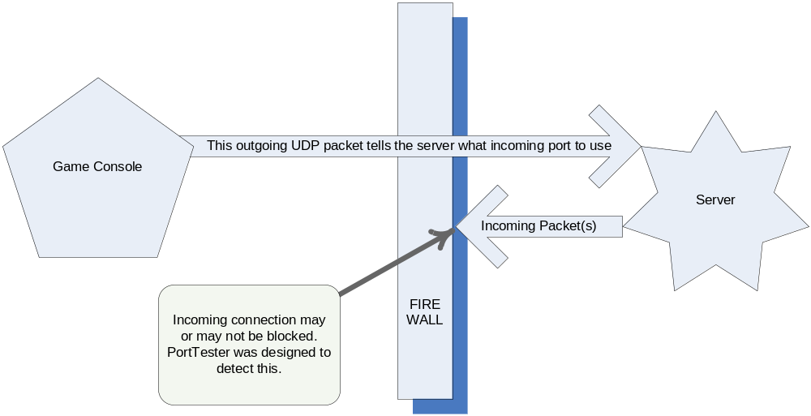

Description:
PortTester is designed to be very easy to use. It requires an active connection to the Lobby server in order to download information about what server and port to initially hit for the return packets. Once PortTester is created and connected, a test can be initiated and the subsequent status can be either polled or communicated via callback to the calling code.

Basic Usage
As with other DirtySock modules, module creation and destruction is performed with PortTesterCreate() and PortTesterDestroy(). Likewise, the create function returns a module state variable which should then be passed to all other PortTester calls, including the destroy function which will free any memory created by PortTester calls.

A server IP address, outgoing server port number, and timeout is passed to PortTesterCreate(). The timeout is the amount of time, in milliseconds, to wait for all responses to come back from the server once the send is complete. The server port number signifies the outgoing port to the server. Make sure the outgoing and incoming ports do not match since this will always work – the outgoing connection will poke a hole in the firewall so the incoming packets will always come through.

Once an active lobby connection is established, inform PortTester with a call to PortTesterConnect(). PortTester will automatically register itself with the lobby for its internal update function. It is not necessary to pump any update function in PortTester. Just make sure the LobbyApiUpdate() function is being called at an appropriate frequency.

To begin a port test using PortTester, call PortTesterTestPort() with the incoming port to test and a callback pointer. If a callback is not desired, pass a NULL value and then use PortTesterStatus() to poll for status updates.

The following diagram shows the sequence of states PortTester goes through. The only way to ensure that all states are received is to register a callback – checking states by polling PortTesterStatus() may result in missing some states.

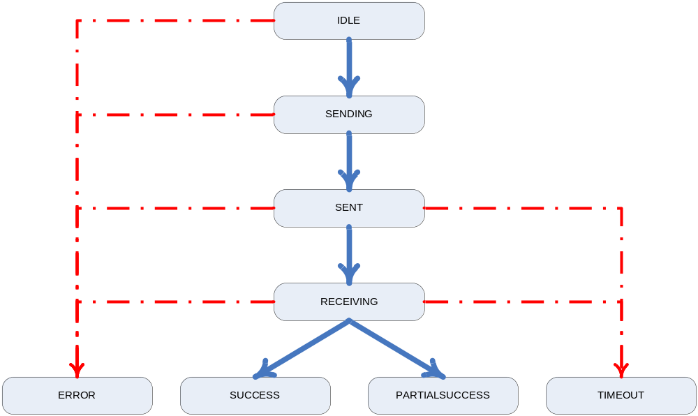

Normal state transitions for a port test with no firewall and complete reception of all UDP packets will follow the path in blue solid lines as shown above. The first time and every subsequent time PortTesterTestPort() is called, the state will be reset to IDLE and will end in either SUCCESS, PARTIALSUCCESS, TIMEOUT, or ERROR. Be sure to wait for a test on one port to complete before testing the next port.

Here are all the possible states PortTester might return:

PORTTESTER_STATUS_IDLE | Waiting for something to do
PORTTESTER_STATUS_SENDING | Sending packets to the server
PORTTESTER_STATUS_SENT | Packets sent, waiting for response(s)
PORTTESTER_STATUS_RECEIVING | Some or all of the packets have been received
PORTTESTER_STATUS_SUCCESS | All packets were successfully received
PORTTESTER_STATUS_PARTIALSUCCESS | Some of the packets were received  before a timeout occurred
PORTTESTER_STATUS_TIMEOUT | A timeout occurred before all packets were received
PORTTESTER_STATUS_ERROR | An error occurred

The PortTesterTestPort() call will send a single command packet to the server. This packet contains information about the sender and the number of response packets to send back. Pass in the incoming port number to use and the number of incoming packets to send. A callback which will publish status updates is optional.

When done testing ports, make sure to call PortTesterDisconnect() to disconnect from the lobby and then PortTesterDestroy() to free any memory the port tester may have used. The disconnect function must be called before the Lobby is disconnected or the module may crash.

For an example of how to use the PortTester, see the tester sample shipped with the DirtySock SDK release under DirtySDK/sample/common/tester.

API:

/*H********************************************************************************/
/*!
\File porttestapi.c

\Description
PortTest is used for testing port connectivity between
a central server and a client using UDP packets.

\Todo
Need to determine what kind of status stuff needs to be shared
in the PortTesterStatusT structure.

\Copyright
Copyright (c) 2005 Electronic Arts Inc.

\Version 03/09/2005 (jfrank) First Version
*/
/********************************************************************************H*/

#ifndef _porttestapi_h
#define _porttestapi_h

/*** Include files ****************************************************************/

#include "lobbydisplist.h" // dependency of lobbyapi.h
#include "lobbyapi.h"

/*** Defines **********************************************************************/

/*** Macros ***********************************************************************/

#define PORTTESTER_ERROR_NONE (0) //!< no error to report
#define PORTTESTER_ERROR_BIND (-1) //!< error binding the socket(s)
#define PORTTESTER_ERROR_BADPTR (-2) //!< bad ref pointer used
#define PORTTESTER_ERROR_BUSY (-3) //!< busy - operation cannot be completed

/*** Type Definitions *************************************************************/

// module state
typedef struct PortTesterT PortTesterT;

// Callback prototype used for status updates, if enabled
typedef void (PortTesterCallbackT)(PortTesterT *pRef, int iStatus);

/*** Variables ********************************************************************/

//! Internal module states
enum PortTesterStateE {
PORTTESTER_STATUS_IDLE = 0, //!< waiting for something to do
PORTTESTER_STATUS_SENDING, //!< sending packets to the server
PORTTESTER_STATUS_SENT, //!< packets sent, waiting for response(s)
PORTTESTER_STATUS_RECEIVING, //!< some or all packets have been received
PORTTESTER_STATUS_SUCCESS, //!< all packets received successfully
PORTTESTER_STATUS_PARTIALSUCCESS, //!< some of the packets received successfully
PORTTESTER_STATUS_TIMEOUT, //!< a timeout occurred before all packets were received
PORTTESTER_STATUS_ERROR, //!< an error occured
PORTTESTER_STATUS_UNKNOWN
} PortTesterStateE;

/*** Functions ********************************************************************/

#ifdef __cplusplus
extern "C" {
#endif

// create a port tester to talk to a server on the specified port
PortTesterT *PortTesterCreate(int iServerIP, int iServerPort, int iTimeout);

// Connect a PortTester to a LobbyAPI
void PortTesterConnect(PortTesterT *pRef, LobbyApiRefT *pLobby);

// Return info based on input selector
int PortTesterInfoInt(PortTesterT *pRef, int iKind);

// Return info based on input selector
const void *PortTesterInfoPtr(PortTesterT *pRef, int iKind);

// PortTester control function
int PortTesterControl(PortTesterT *pRef, int iSelect, int iValue);

// Test a specified port based on the information already provided and use callback if non-NULL
int PortTesterTestPort(PortTesterT *pRef, int iPort, int iNumPackets, PortTesterCallbackT *pCallback);

// Get the module status (PORTTESTER_STATUS_XXXX) and return info in pStatus if non-NULL
int PortTesterStatus(PortTesterT *pRef);

// Disconnect a PortTester from a LobbyAPI
void PortTesterDisconnect(PortTesterT *pRef);

// Destroy a PortTester module
void PortTesterDestroy(PortTesterT *pRef);

#ifdef __cplusplus
};
#endif

#endif // _porttestapi_h

